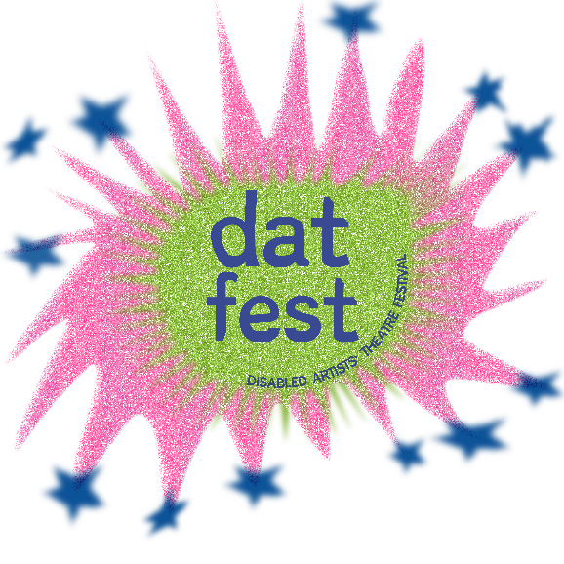
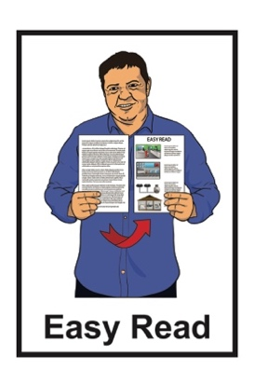

DAT Fest Shared Expectations
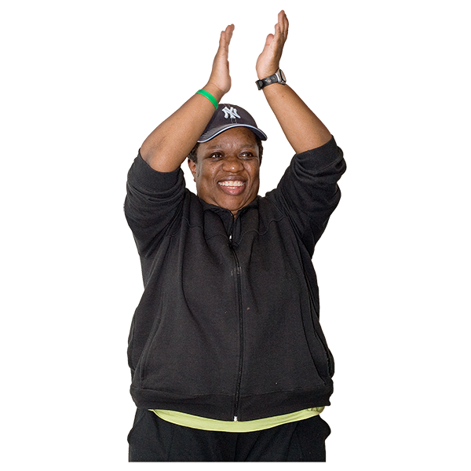
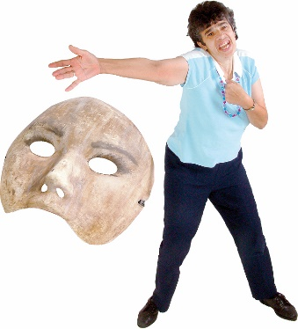

Published: October 2024

About this Easy Read

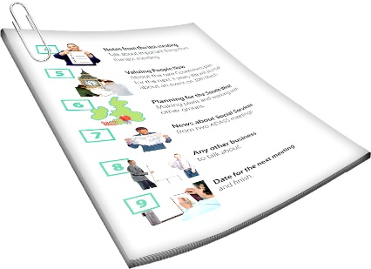
This Easy Read is the shared expectations for DAT Fest.

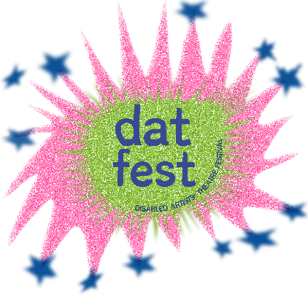
DAT Fest is short for Disabled Artists’ Theatre Festival.

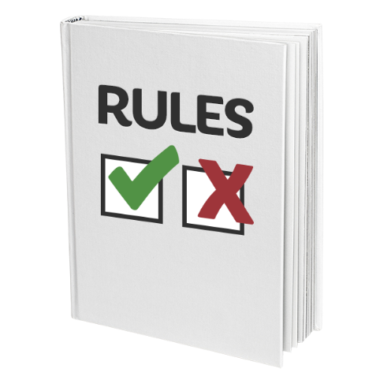
The shared expectations are like a list of rules to keep everyone:
safe
well.

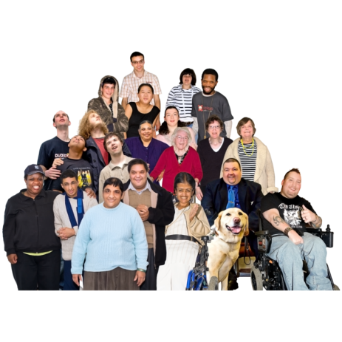
Everyone at DAT Fest should follow the shared expectations.

DAT Fest is for DDN people.
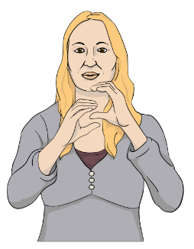
DDN is short for:
Deaf / deaf
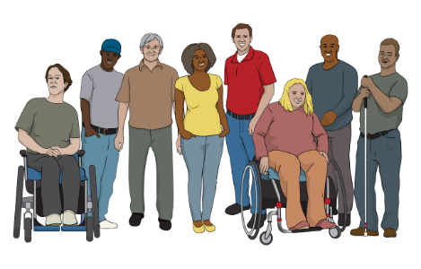
disabled
neurodivergent.

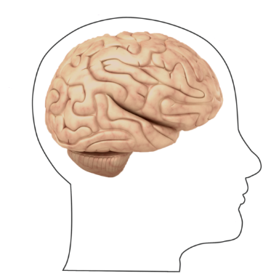
Neurodivergent people have brains that work differently from most other people in lots of different ways.

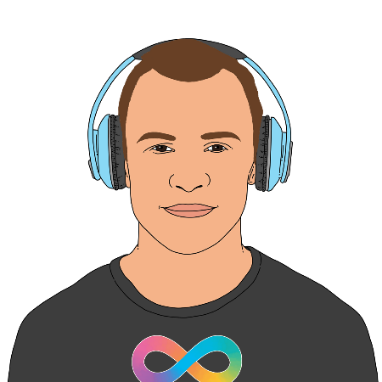
Neurodivergent includes people who:
are autistic
have ADHD.

Shared expectations

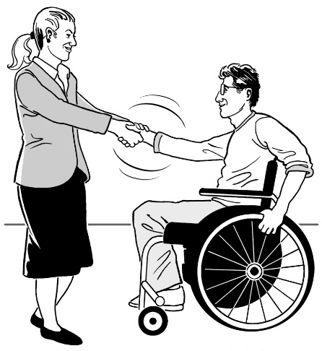
It is important to treat everyone in a way that is:
respectful
kind.

We are all different.

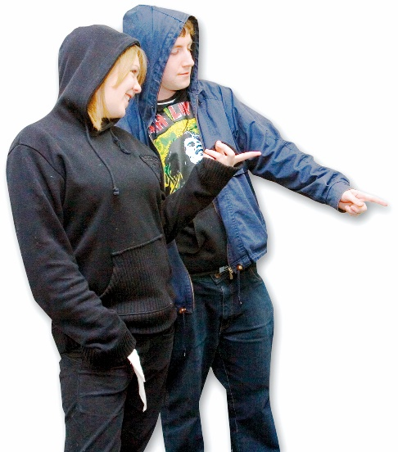
Do not:
treat people badly

use words that are likely to upset people.

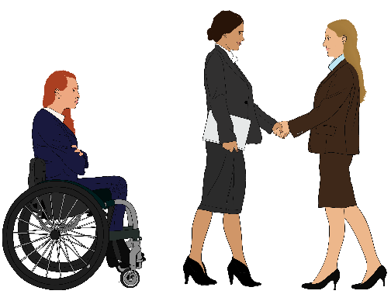
This also means not treating people unfairly because of things like:
- how they are disabled
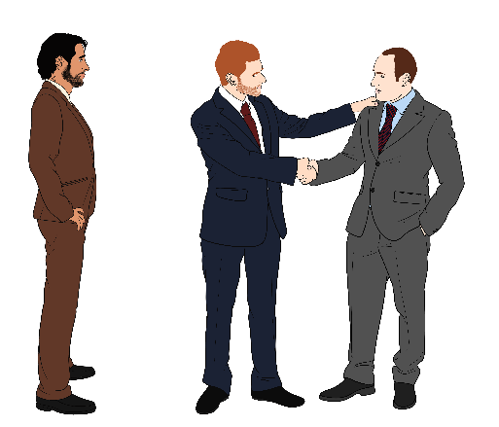
- their gender
- their race / ethnicity
- age.
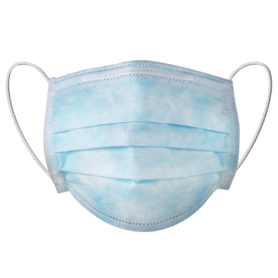

Please wear a face mask if you can.


Please stay at home if you have an illness other people might catch like:
COVID-19
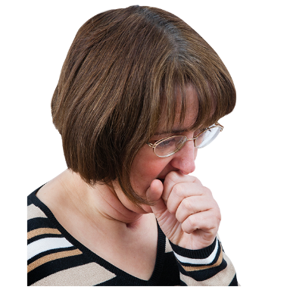
a cold
the flu.

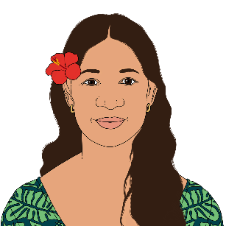
Unless the person says it is okay please do not touch:
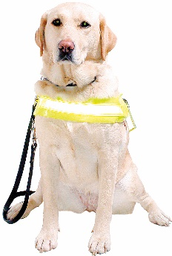
people
dogs
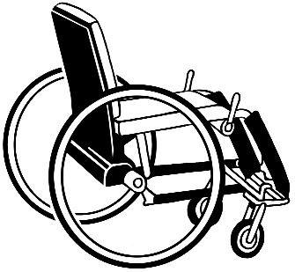
mobility aids like wheelchairs or crutches.

Please ask first if you want to:
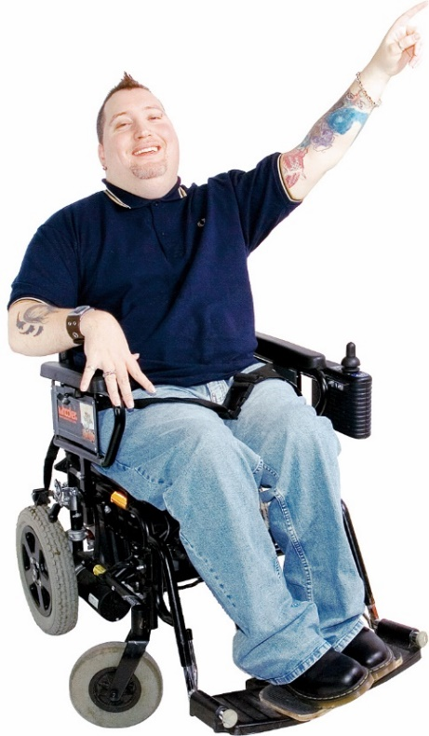
assist someone
give someone advice
ask someone about their disability
tell someone how you think they could do better.

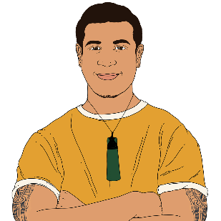
Remember that for some people:
you cannot easily tell if they are disabled by looking at them
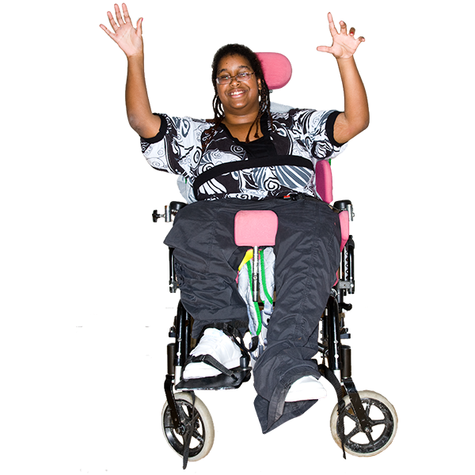
how their disability affects them changes.

For example a person might:
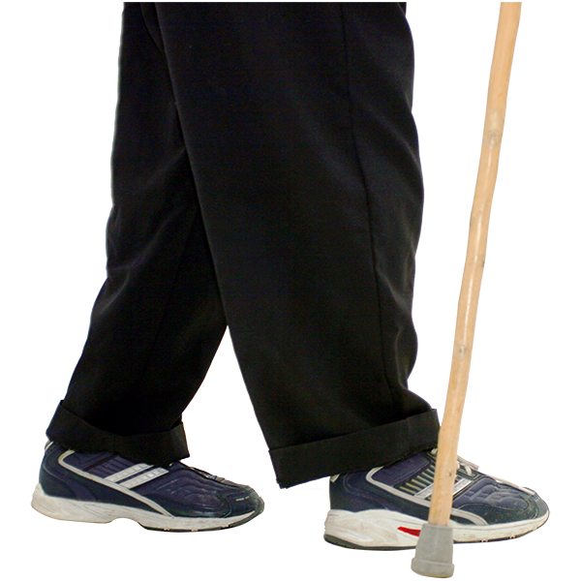
sometimes use a wheelchair
walk at other times.

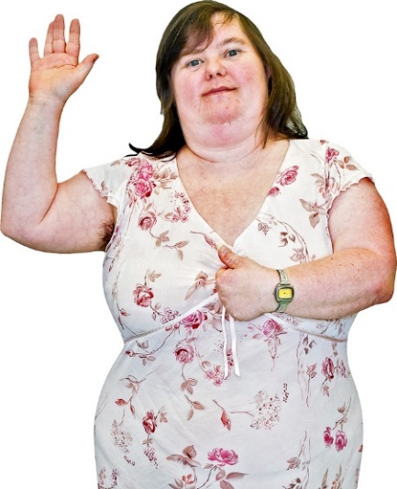
Call people by the:
names they ask you to
right pronouns.

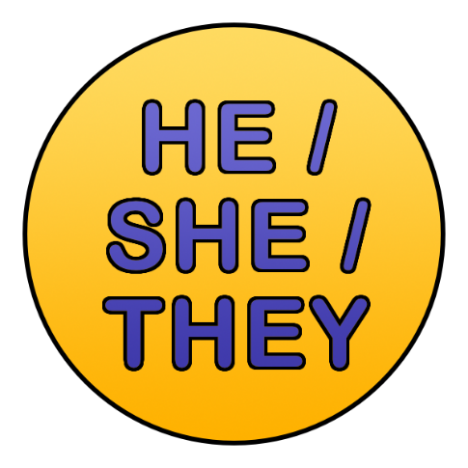
Pronouns are words we use in place of names like:
he / him / his
she / her
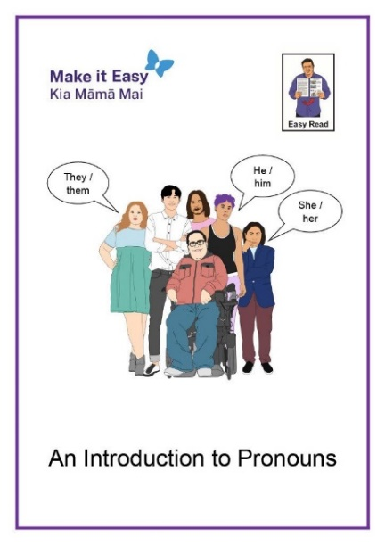
they / them / their.

There is an Easy Read document with more information on pronouns.

You can find it at:

www.peoplefirst.org.nz/easy-read-library/
resource/introduction-to-pronouns

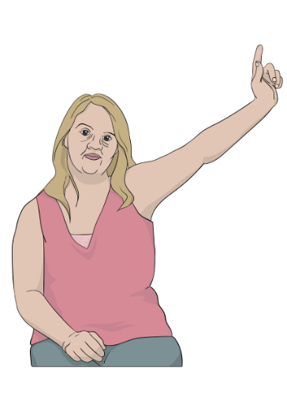
It is okay to ask someone for their name or pronouns if you:
are not sure
forget.
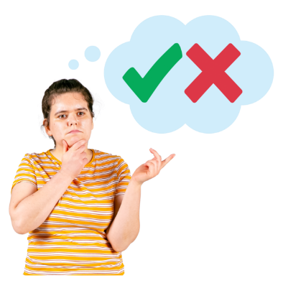
Please treat everyone as a person who can make their own decisions.

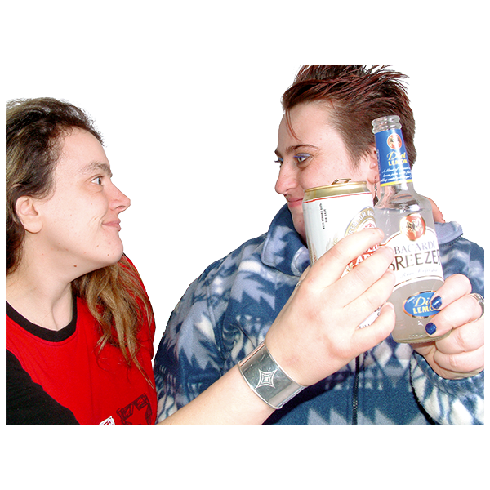
There is a bar at the place we are having DAT Fest.

It is ok to have a drink there.


Please do not:
get drunk
bring your own alcohol.

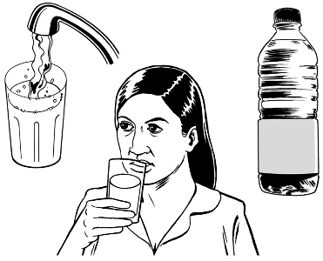
Do what you need to look after yourself.

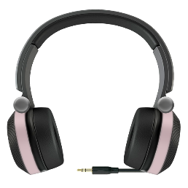
Let other people do what they need to look after themselves.

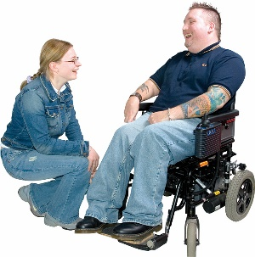
It is okay if you want to:
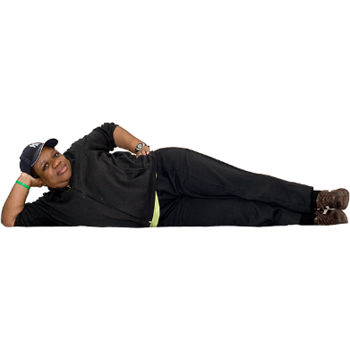
bring a support person
lie on the floor
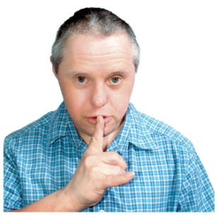
leave the room
go to the quiet space.
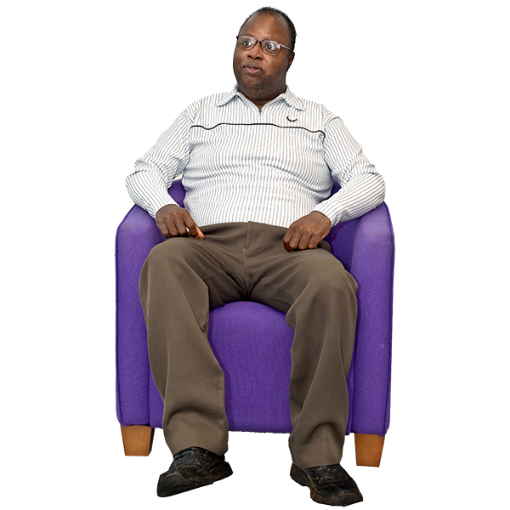

The quiet space is a room you can go to if you need it to be quiet.

Please tell the DAT Fest team if you:
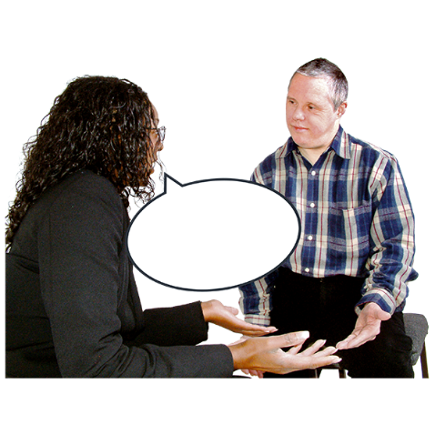
are going to be late
are unwell
need something
are too tired to do things.

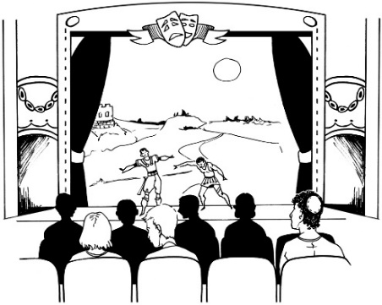
If you are watching a show please be a good audience member by paying attention to the show.

It is okay that different people pay attention in different ways.

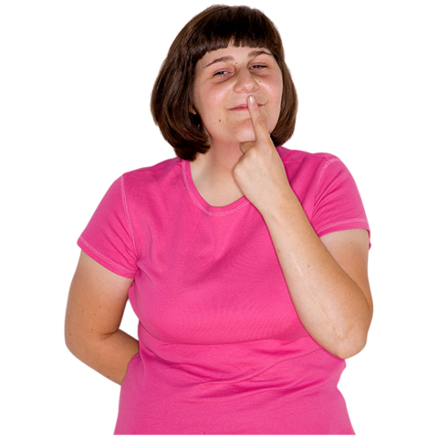
You do not have to say what kind of disability you have if you do not want to.

Everyone will know that people at DAT Fest are DDN in some way.

If you need support

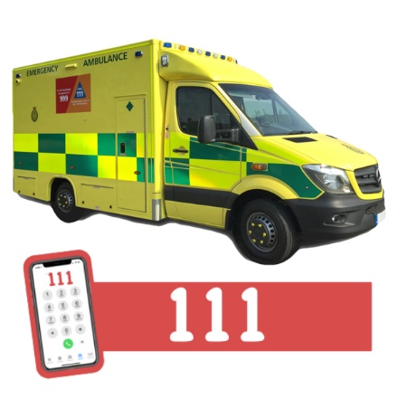
If it is an emergency like someone is badly hurt call:

111

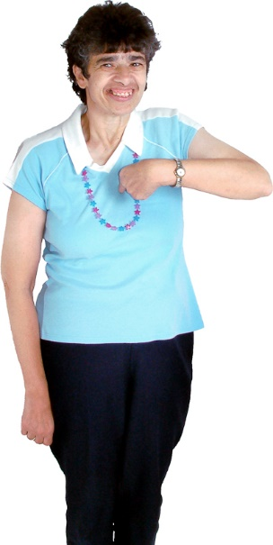
At other times you can find one of the Wellbeing Wingpeople.

Wellbeing Wingpeople are people who are there to make sure
everyone is doing okay.

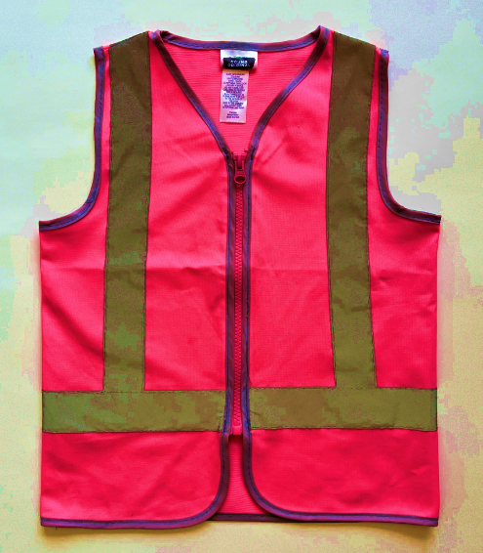
They will be wearing:
bright pink vests
little bells.
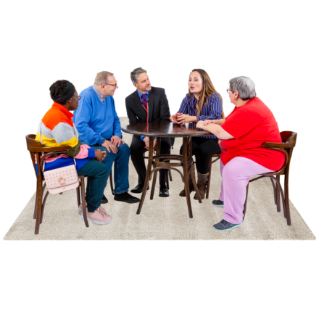
You can also:
find a member of the DAT Fest team
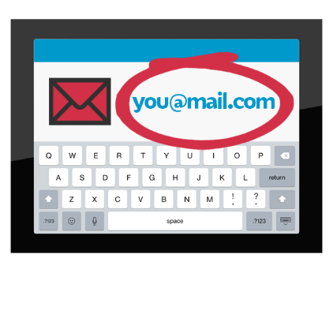
email:
hello.datfest@gmail.com
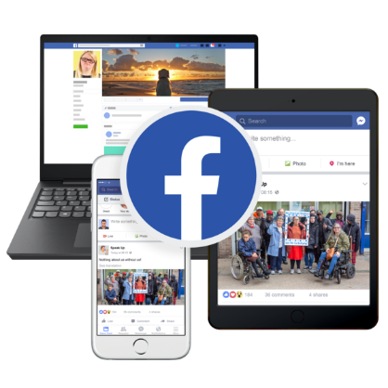
message the Facebook Page at:
www.facebook.com/DATFest


You can find more information about DAT Fest at:

www.datfest.nz

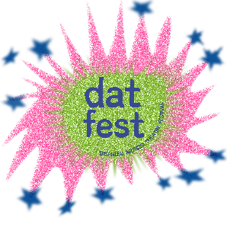
This information has been written by DAT Fest.

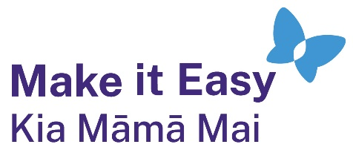
It has been translated into Easy Read by the Make it Easy Kia Māmā Mai service of People First New Zealand Ngā Tāngata Tuatahi.
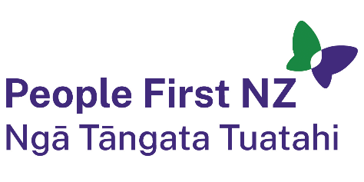
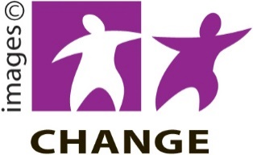
The ideas in this document are not the ideas of People First New Zealand Ngā Tāngata Tuatahi.

Make it Easy uses images from:


- Changepeople.org

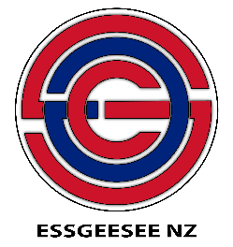
            - Photosymbols.com

- SGC Image Works
- Huriana Kopeke-Te Aho
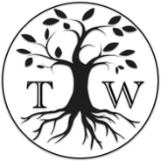
- T. Wood.

All images used in this Easy Read document are subject to copyright rules and cannot be used without permission.

