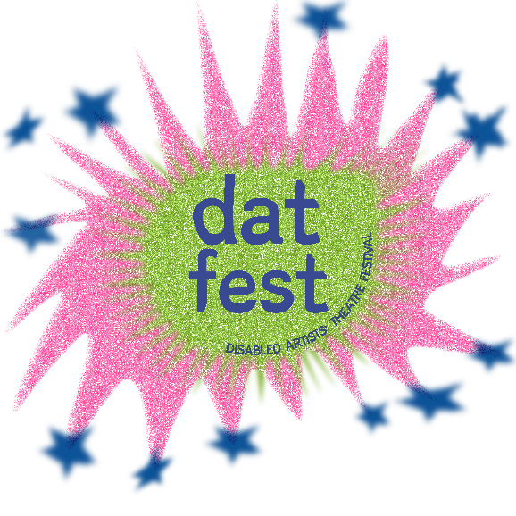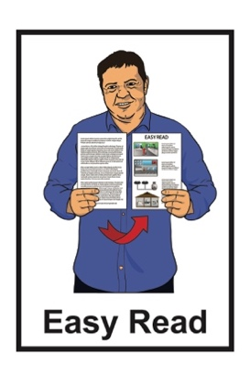

DAT Fest Kaupapa and Goals

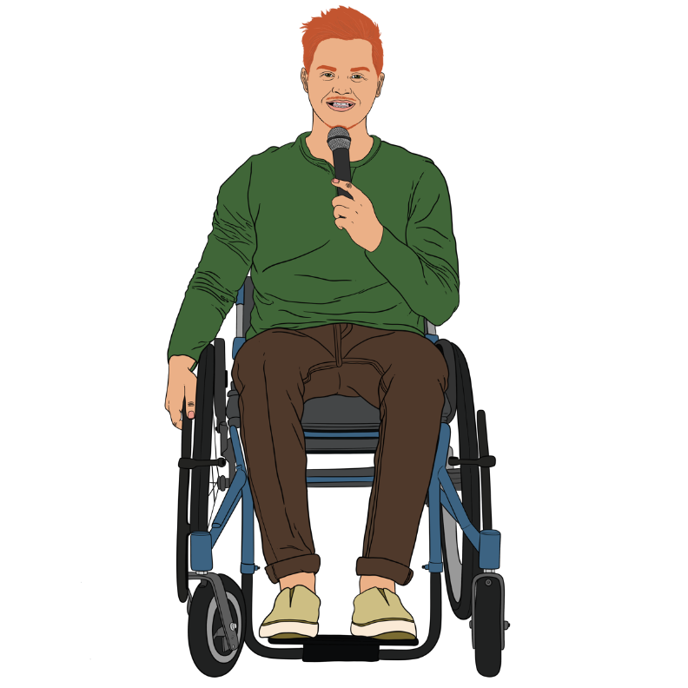

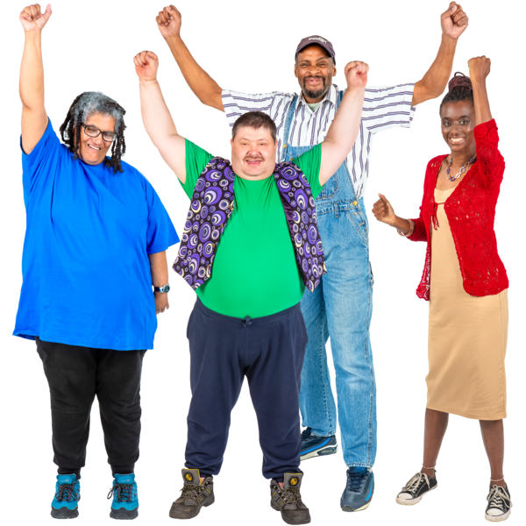

Published: October 2024

# DAT Fest Kaupapa

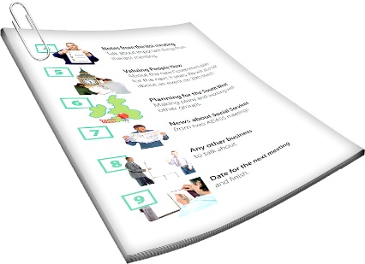

The first part of this Easy Read is the DAT Fest **kaupapa**.

A **kaupapa** says:

what an organisation is there for

why what it does is important.

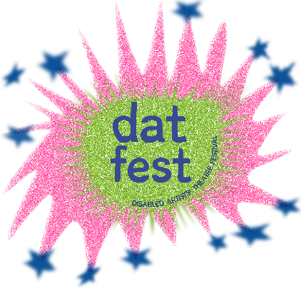DAT Fest is short for Disabled Artists’ Theatre Festival.

It is a 2 week festival in Wellington.

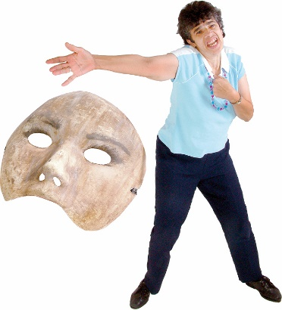

It is made to show theatre / **performance** by **DDN** people.

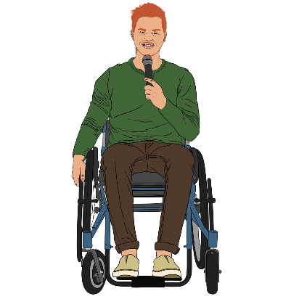**Performance** includes things like:

live comedy

reading poetry out loud.

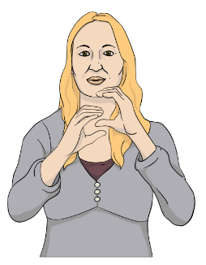

**DDN** is short for:

Deaf / deaf

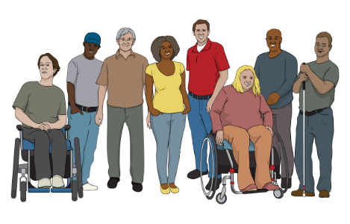disabled

**neurodivergent**.

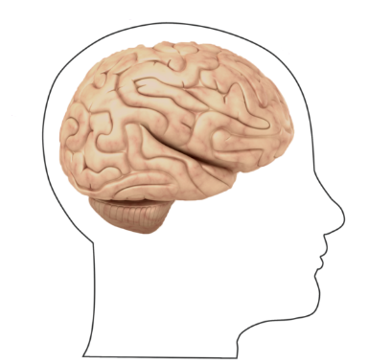

**Neurodivergent** people have brains that work differently from most other people in lots of different ways.

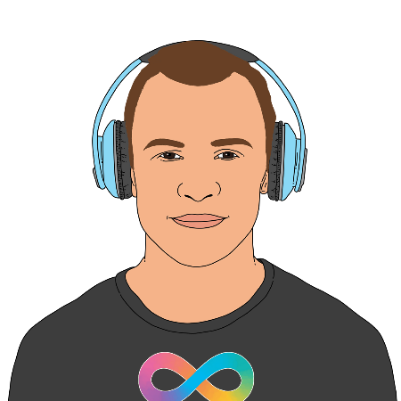

Neurodivergent includes people who:

are autistic

have ADHD.

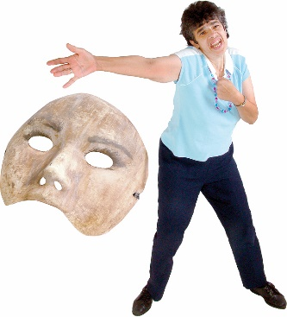DAT Fest is also to encourage DDN people to take part in theatre / performance.

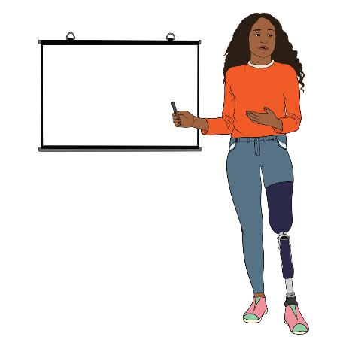DAT Fest is led by DDN people.

The performances are by DDN people.

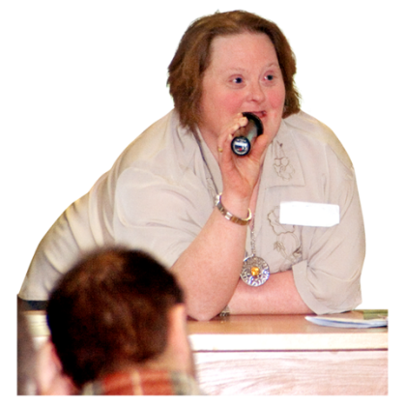

DAT Fest gives DDN people the chance to:

practise

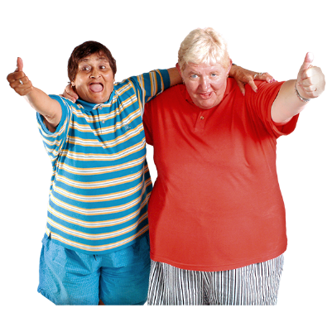learn new things

get to know each other.

# DAT Fest Goals

The things in this part of the Easy Read are our goals.

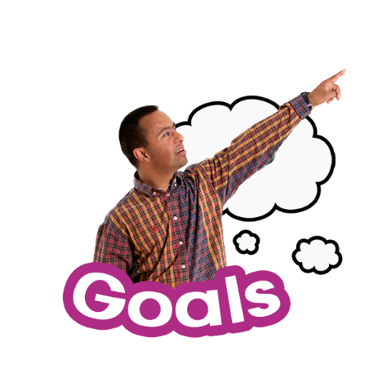

**Goals** are things we want to make happen.

Our goals are to:

* 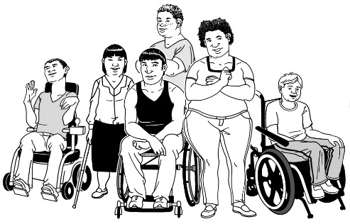make **accessible** **opportunities** for DDN performers / creatives

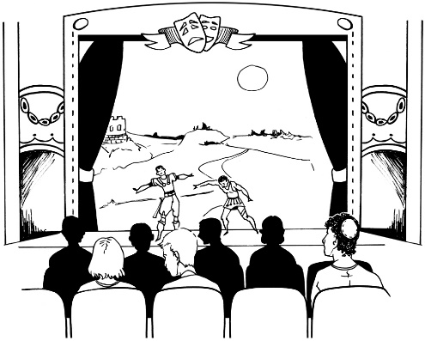offer shows everyone can go to that are:

* accessible
* welcoming.

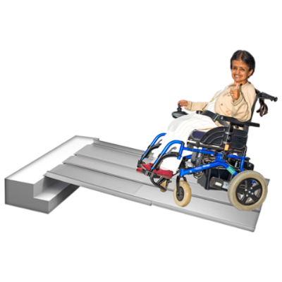**Accessible** means it works well for disabled people.

**Opportunities** are when you get the chance to be part of something.

Our goals are also to:

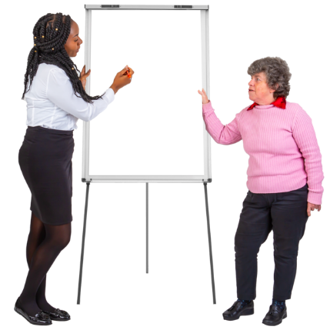offer workshops to DDN performers that are

* accessible
* **relevant**

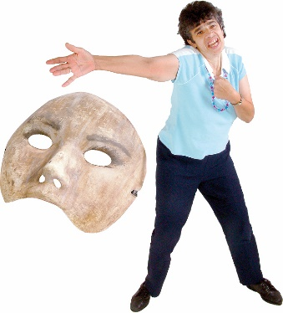support DDN performers / creatives to:

* learn to do new things
* 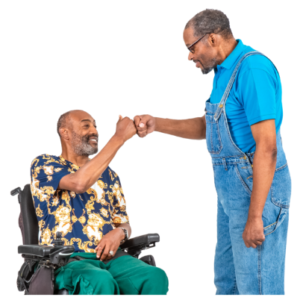present / perform their work
* hang out with other people like them.

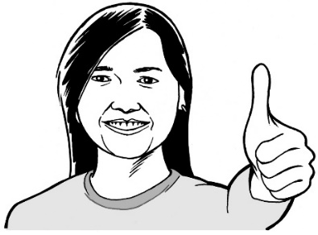**Relevant** means they are a good fit for what people need.

Another goal is to **lead by example**.

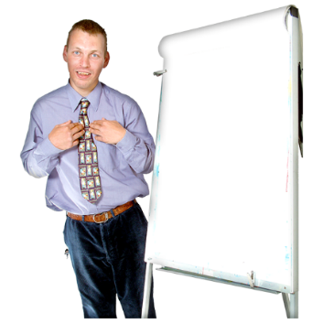

**Leading by example** means doing things the right way not just telling other people to do them.

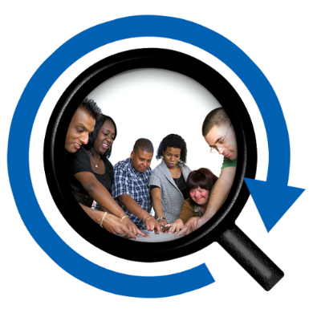

For us this means:

keeping **intersectionality** at the centre of our work

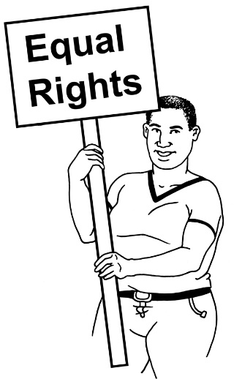making sure we include   
everyone

working in a way that fits with **human rights**.

****Here **intersectionality** means understanding that things are not the same for all DDN people.

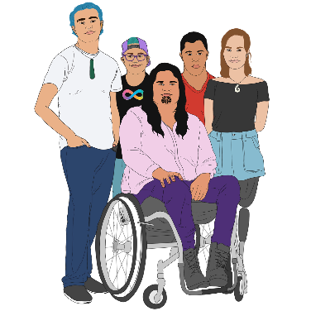

Things are different for people who are also in other groups like:

Māori DDN people

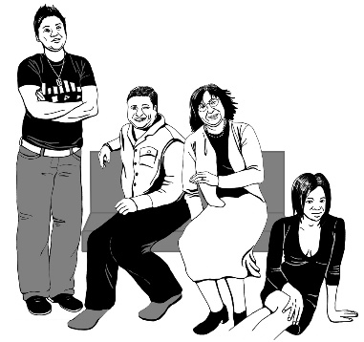**transgender** DDN people.

**Transgender** people are people who have a different gender to the one people thought they had when they were born.



**Human rights** are the basic rights everyone has like:

having a safe place to live

being able to say what you think.

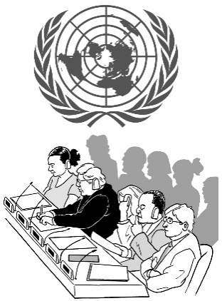We think about things like:

the **United Nations Convention on the Rights of Persons with Disabilities**

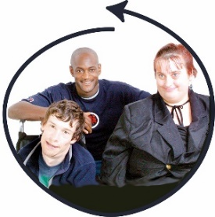**Nothing About Us Without Us**.

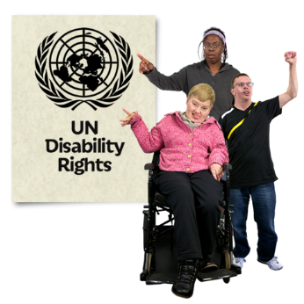The **United Nations Convention on the Rights of Persons with Disabilities** is a law lots of countries have agreed to.

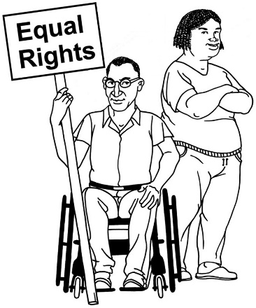

It says what governments must do to make sure disabled people get the same rights as everybody else.

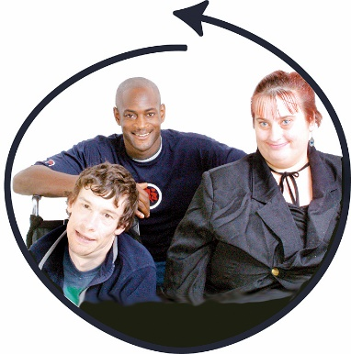**Nothing About Us Without Us** is a saying that has been used in disability rights for a long time.

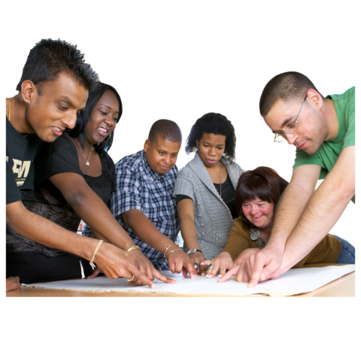It means disabled people:

should be part of making any decisions that affect them

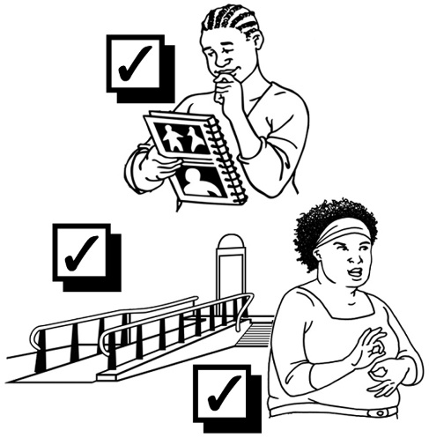not have decisions made about them by people who are not disabled.

We make sure accessibility is at the centre of everything we do.

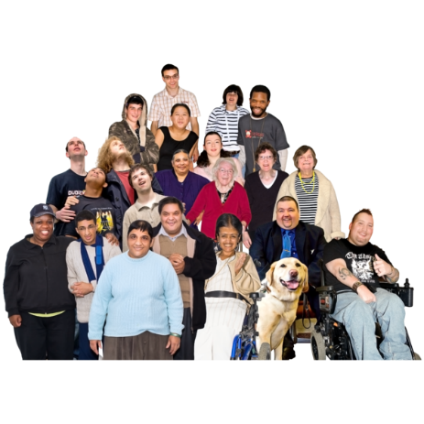

We do our best for everyone who is part of the festival.

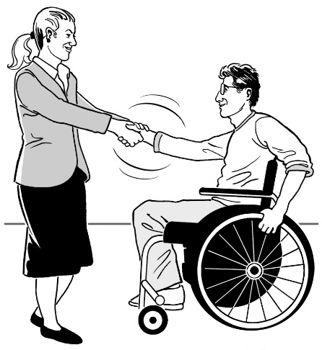We respect:

the limits people have

the different things people need.

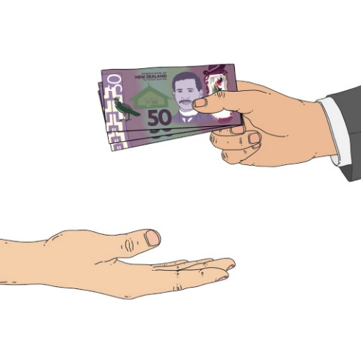

We **contract** DDN people when we can.

**Contract** means paying them money to do things we need.

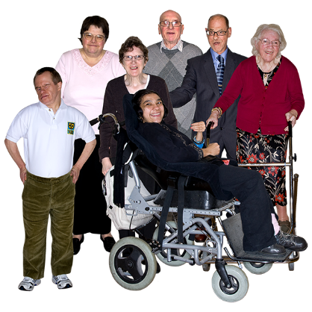

This means:

* we support our communities
* 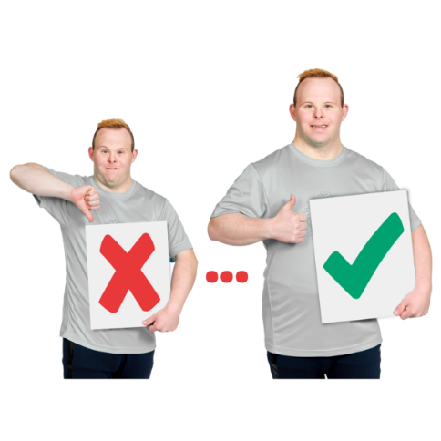DDN people can learn new things.

We always try to do better.

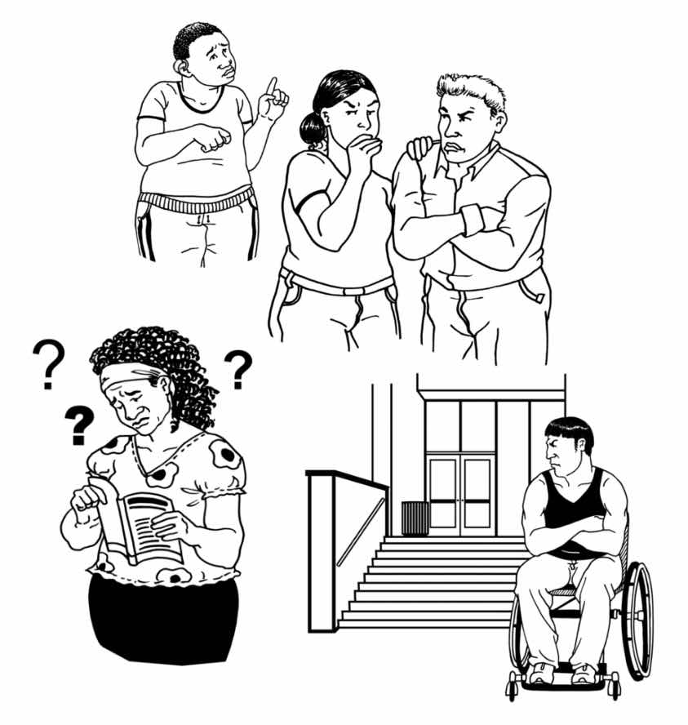No festival is perfect.

Nothing is accessible for everyone in every way.



We do our best to keep:

learning

changing.

# More information

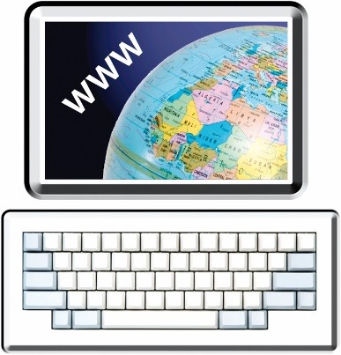

You can find more information about DAT Fest at:

[**www.datfest.nz**](http://www.datfest.nz)

You can also email us at:

[**hello.datfest@gmail.com**](mailto:hello.datfest@gmail.com)

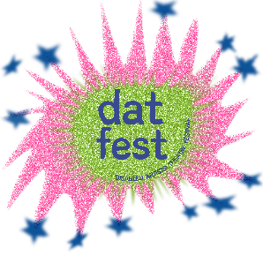This information has been written by DAT Fest.

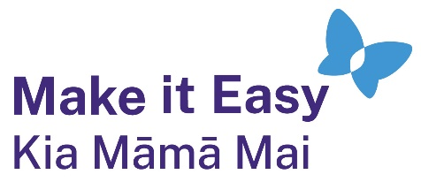It has been translated into Easy Read by the Make it Easy Kia Māmā Mai service of People First New Zealand Ngā Tāngata Tuatahi.

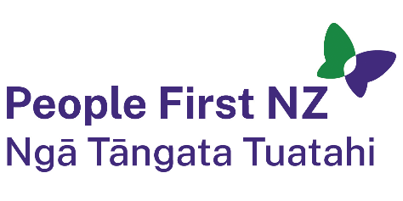

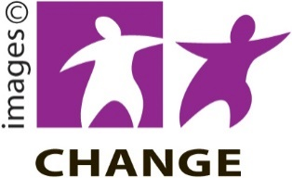The ideas in this document are not the ideas of People First New Zealand Ngā Tāngata Tuatahi.

Make it Easy uses images from:

* Photo SymbolsChangepeople.org

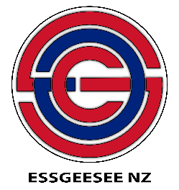Photosymbols.com

* SGC Image Works
* Huriana Kopeke-Te Aho
* 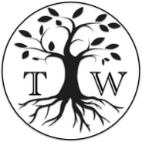T. Wood.

  
All images used in this Easy Read document are subject to copyright rules and cannot be used without permission.